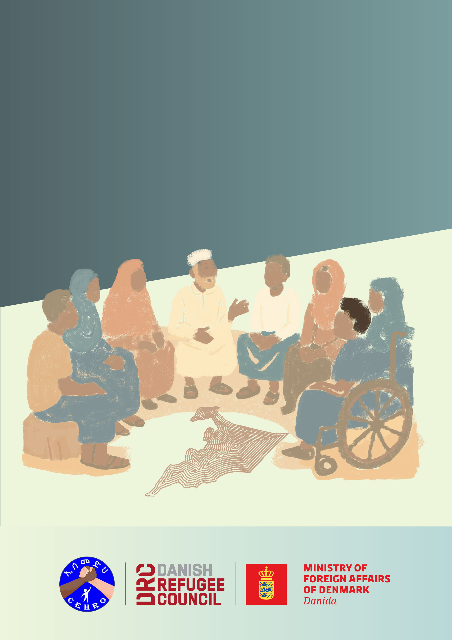
Durable Solutions Monitoring Toolkit

Annex 5: Monitoring Steering committee training guide

1. Purpose of the training
The training aims to equip the Monitoring Steering Committee members with the knowledge, skills, and tools required to effectively guide, oversee, and support durable solutions monitoring at the woreda level. It ensures that the committee can fulfil its roles in an inclusive, accountable, and sustainable manner.

2. Learning objectives
By the end of the training, participants will be able to:

- Understand the objectives and methodology of the Durable Solutions Monitoring Toolkit.
- Clarify the roles and responsibilities of the Steering Committee in the durable solution initiative monitoring.
- Strengthen skills in inclusive community engagement, data oversight and findings validation.
- Promote accountability, transparency, and increase awareness on safe and participatory feedback mechanisms.
- Build ownership and collective action among communities, authorities, and implementing partners.

3. Target participants
The training will be provided to members of the woreda-level Steering Committee, including:
- Representatives from affected communities: including displaced persons, host community members, marginalized groups, women, youth, elders, and persons with disabilities.
- Local authority representatives from DRM office.
- Civil society organisations, NGOs, community-based organisations, faith-based groups in the Woreda.
- External data collectors

4. Training agenda
Section | Content | Description of Activities | Methodology | Time
1 | Introduction to Durable Solutions Monitoring | Explain the displacement challenges and durable solutions framework | - Short Presentation  - Group discussion on what the durable solution perception in the specific location’s context | 60 min
1 | Introduction to Durable Solutions Monitoring | Introduce the durable solution monitoring toolkit purpose, Indicators and process |  | 60 min
Tea Break

2 | Roles and responsibilities of the Steering committee | Clarify mandate of the Steering Committee | - Role Mapping Exercise  - Review different case study or lived experience and good practices | 45 min
2 | Roles and responsibilities of the Steering committee | Define specific tasks (such as data collection, Monitoring, data validation, advocacy and feedback) |  | 45 min
3 | Inclusive Representation & Community engagement | Identify and Introduce strategies to ensure diversity (inclusion of women, youth, people with disabilities, marginalised groups) | - Group work and role play | 60 min
3 | Inclusive Representation & Community engagement | Awareness on safe and ethical participation | - Group work and role play | 60 min
Lunch

4 | Monitoring, Data collection oversight and validation | Awareness on data collection tools proper use (practical exercise), data collection ethics, on spot data quality check and validation methods | - Short Presentation  - Group work | 45 min
5 | Feedback, Reporting, Advocacy and action planning | Introduce available mechanism for feedback mechanism and how to use. | - Presentation  - Group discussion | 60 min
5 | Feedback, Reporting, Advocacy and action planning | Introduce the durable solution monitoring reporting, validation procedures and timelines | - Presentation  - Group discussion | 60 min
5 | Feedback, Reporting, Advocacy and action planning | Introduce how the data collected can be used for advocacy and improvement plan | - Presentation  - Group discussion | 60 min
Tea Break

6 | Recap & Closure | Review key concepts covered, reflect on participants learning comments and questions, agree on next steps of the durable solution data collection and relevant action items | - Round Robin Recap (each participant will share one key takeaway)  - Sticky note wall/parking Lot/tree of learning (Participants write their learning on sticky | 30 min
6 | Recap & Closure | Provide empowering closure to strengthen motivational |  | 30 min

