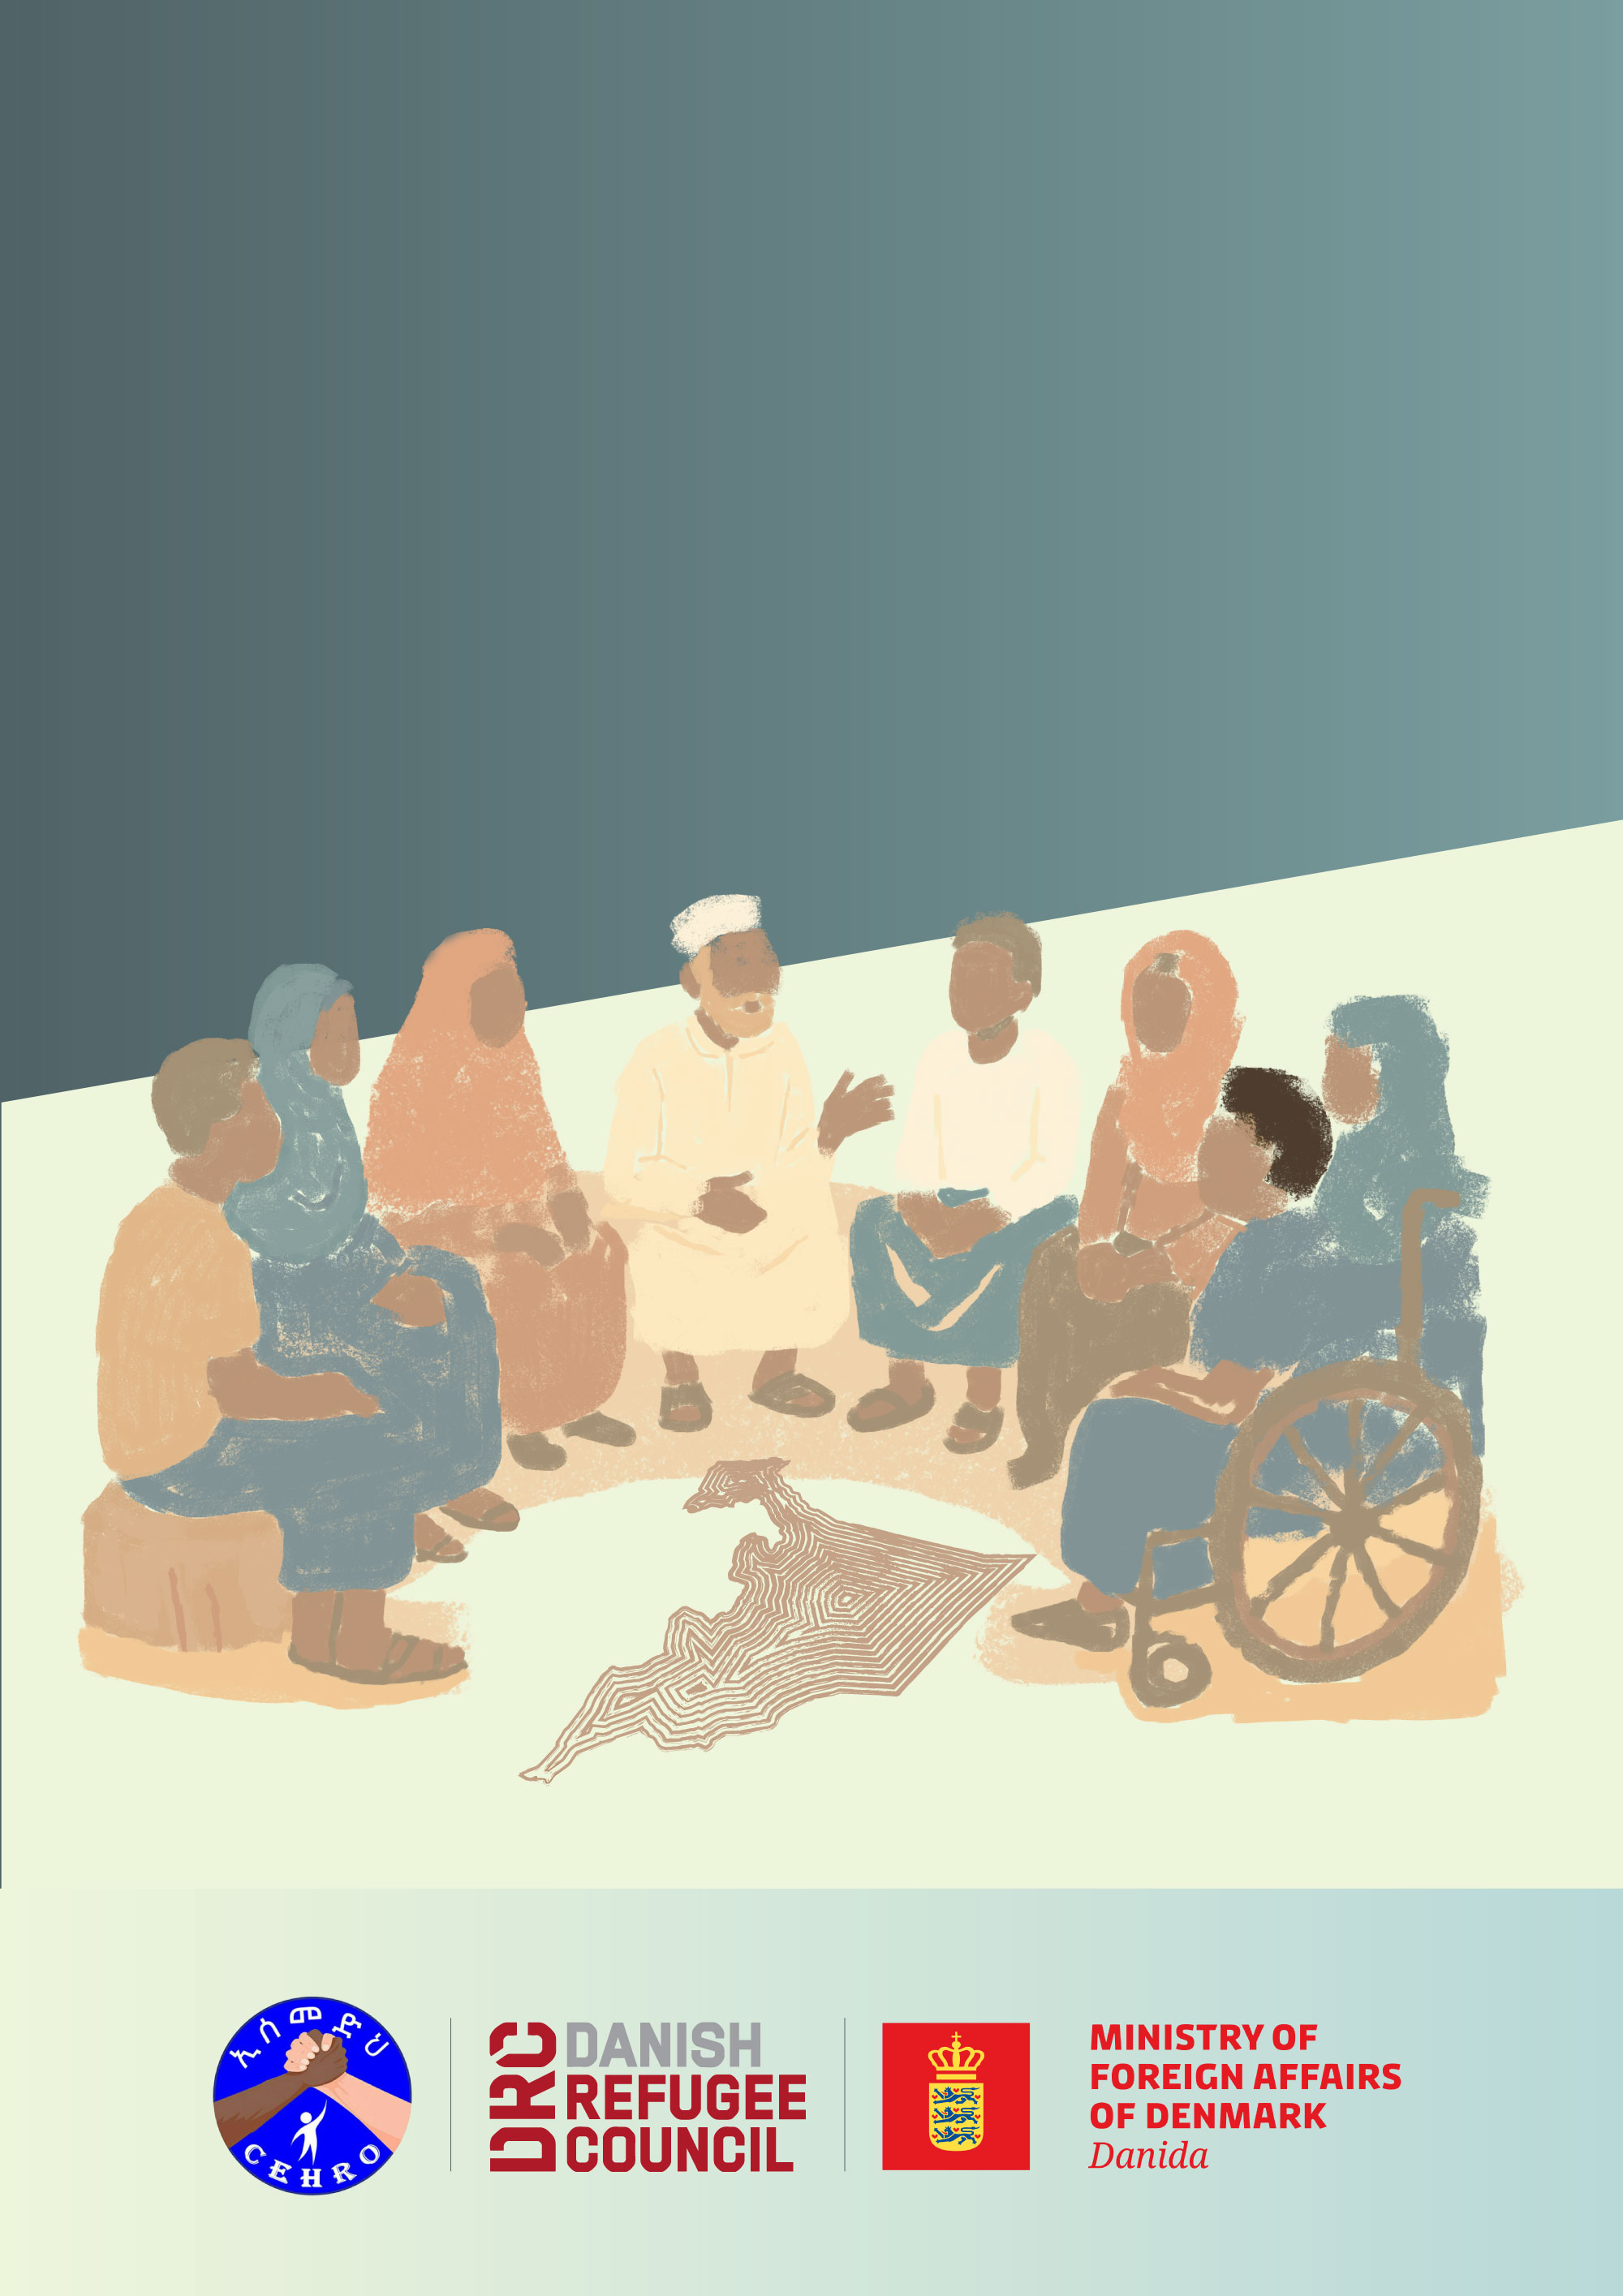
Durable Solutions Monitoring Toolkit

Annex 7: Simple guidance on sampling for surveys and group discussions
Annex 7: Simple guidance on sampling for surveys and group discussions

1. What is sampling?
Sampling is a way to collect information from part of a community when it is not possible to ask everyone. Instead of interviewing every household, we select a smaller number of people or families to represent the larger group.
To be useful, the sample should be like a miniature version of the wider community, so that the findings reflect the views of different groups, not only a few.

2. Who to include?
- The goal is to make the sample as representative of the community as possible, meaning no group is left out.
- Avoid only asking people you already know, or only those who are most visible (like leaders or outspoken members), as this can create bias. Instead, use a structured method rather than hand-picking. For example:
  - In a village, start at a central point and interview every 3rd or 5th household (systematic random sampling).
  - In larger sites, divide the area into zones and select households evenly across them.
- If the target group (e.g. IDPs) is mixed with others and hard to identify, you can use local knowledge to find participants or use a “snowball” approach but be aware this is non-random and may bring more bias.
- Always make sure different voices are included (women, men, youth, older persons, persons with disabilities).

3. How many people to ask?
- The number of interviews depends on the size of the community. Larger sites need bigger samples to reflect everyone’s views, while smaller sites can work with fewer.
- As a rule of thumb, for quantitative tools such as Household surveys:
  - In small sites (around 300 households or fewer), try to survey about 100 households. In larger sites, aim for around 250 households per location. This number is usually enough to capture reliable trends, even in big populations, without making data collection too heavy.
- For qualitative tools (such as FGDs and KIIs), the goal is diversity and depth, not numbers. Ideally, keep collecting views until you start hearing the same ideas repeated. This means you’ve reached saturation.
  - Focus Group Discussions: Organise groups of 5-7 people. Hold at least 2-3 FGDs so you hear different perspectives. Again, for FGDs, the goal is diversity.
    - You can organise separate groups (for example, one with only women, one with only men, one with only youth, one with persons with disabilities).
    - Or you can organise mixed groups. In that case, make sure there is a good balance of participants and that everyone gets the chance to speak, not only the same people or the most outspoken.
  - Key Informant Interviews: Speak to 5-10 key people per location (authorities, service providers, community leaders).

4. How to interpret the findings?
- Remember that this is not a scientific survey. The results will not give exact percentages for the whole population.
- •Instead, the data shows main trends and community priorities. Use it to guide discussions, decisions, and advocacy.
- •Always combine survey results with what you hear in FGDs and KIIs to get the full picture.
- •It is better to collect some information in a fair and inclusive way than to aim for perfect numbers. The goal is to hear from many voices and use that evidence to inform action.

