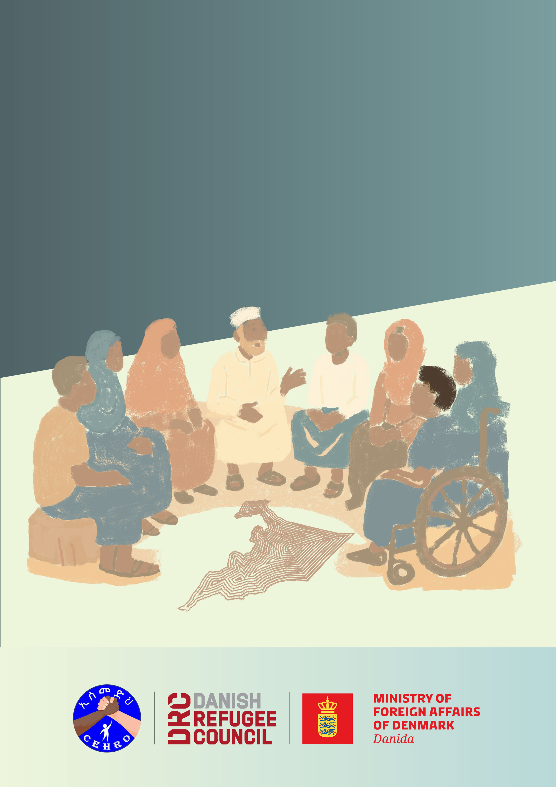
Durable Solutions Monitoring Toolkit

Annex 6: Guidelines for community-based data collection
This annex provides practical guidance for steering committees, community members, and partners who are engaged in monitoring displacement-affected communities. It aims to ensure that data collection is safe, ethical, inclusive, and reliable.

1. Purpose of data collection
- Collect evidence that reflects community realities.
- Inform joint analysis and decision-making.
- Strengthen accountability by making community voices central.

2. Steps for community-based data collection
Step 1 : Preparation
- Steering committees review tools to ensure cultural relevance and agree on the best translation for the key terms used in the tools.
- Data collectors (from the community) are trained on ethics, interviewing techniques, and recording responses.
Step 2 : Sampling and recruitment
- MEAL staff decide how many households/participants are needed. If there are no MEAL staff involved, see Annex 7 for practical tips on how to select respondents fairly and how many to include.
- Steering committees help identify diverse participants (displacement status, gender, age, disability).
Step 3 : Conducting data collection
- Always introduce yourself, explain the purpose, and seek consent.
- Use simple, clear language; avoid jargon.
- Ensure privacy (interviews should not be overheard).
- Allow participants to skip questions or stop at any time.
Step 4 : Quality assurance
- MEAL focal points check that forms are complete and consistent.
- Daily debriefs between data collectors and MEAL staff help catch mistakes early.
- Random spot-checks (supervision visits) ensure reliability.
Step 5 : Data management
- Responses are anonymised (remove names).
- Data is entered into the monitoring template or digital tool (if used).

Roles and responsibilities
- MEAL focal points: Lead technical aspects (sampling, tool adaptation, training, data entry/analysis, quality control).
- Community data collectors: Gather information ethically and respectfully.
- Steering committees: Oversee the process, validate findings, and ensure inclusivity.
- DSWG and authorities: Use findings for decision-making and accountability.

Practical tips
- Pilot-test tools in one site before wider use.
- Translate key questions into local languages and test for clarity.
- Use visual aids (pictures, icons) if required for low-literacy participants.
- Build trust: explain that participation will not affect aid or entitlements.
- Keep sessions short (no more than 45 to 60 minutes).

Using data for advocacy and change
Advocacy is about turning evidence into action. The goal is to make sure that the realities, priorities, and solutions identified by displacement-affected communities influence the decisions of those who design policies, allocate budgets, and deliver services. Without advocacy, data risks remaining in reports rather than driving real change in people’s lives.
Community-based monitoring generates powerful evidence because it comes directly from those affected. When shared strategically, this evidence can:
- Strengthen accountability: Show whether commitments made by government or humanitarian actors are actually being met.
- Mobilise resources: Highlight urgent gaps in services (e.g. water, shelter, livelihoods) and attract funding or partnerships to fill them.
- Shape policies and strategies: Provide a reality check to make sure durable solutions plans reflect community priorities.
- Amplify community voices: Create space for committees and representatives to speak directly to decision-makers, reducing the risk that their concerns are overlooked.
Examples of how monitoring data can be used in advocacy:
- Local committees use monitoring results to request additional water points or health services from woreda authorities.
- Findings on housing or land access are presented to regional government to guide land allocation strategies.
- Evidence on school attendance gaps is shared with education authorities and donors to adjust programming.
- Monitoring trends are used by the Durable Solutions Working Group to advocate for budget allocations in the next regional plan.

